Ex: 1 | Private Cloud using OpenStack
Date:24/06/2026 | Private Cloud using OpenStack

Aim
To create a private cloud environment by installing and configuring OpenStack (MicroStack) on a single Ubuntu system. The experiment also helps in learning how cloud resources such as virtual machines, networking, and storage are managed in a private cloud.

What is Openstack?
OpenStack is an open-source cloud platform used to build and manage cloud infrastructure. It is mainly used for Infrastructure as a Service (IaaS), where users can create and control virtual machines whenever required. It provides services for computing, networking, and storage in a cloud environment.

What is Microstack?
MicroStack is a lightweight version of OpenStack that runs on a single computer. It is mainly used for learning, testing, and small-scale development. Since it requires only minimal configuration, it is a good choice for beginners who want to understand how OpenStack works.

Procedure
Step 1: Create a new Ubuntu virtual machine using Oracle VirtualBox with the following configuration:
- Memory: 8 GB RAM
- Processor: 4 CPU Cores
- Storage: 20 GB Virtual Disk

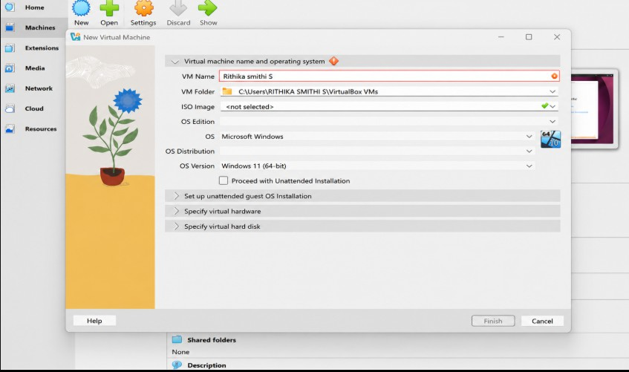
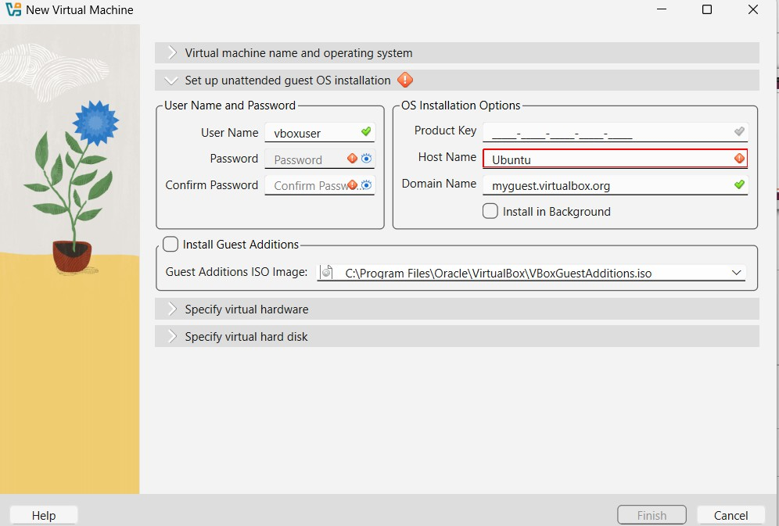

Step 2: Install the Ubuntu operating system and log in using the username and password created during installation

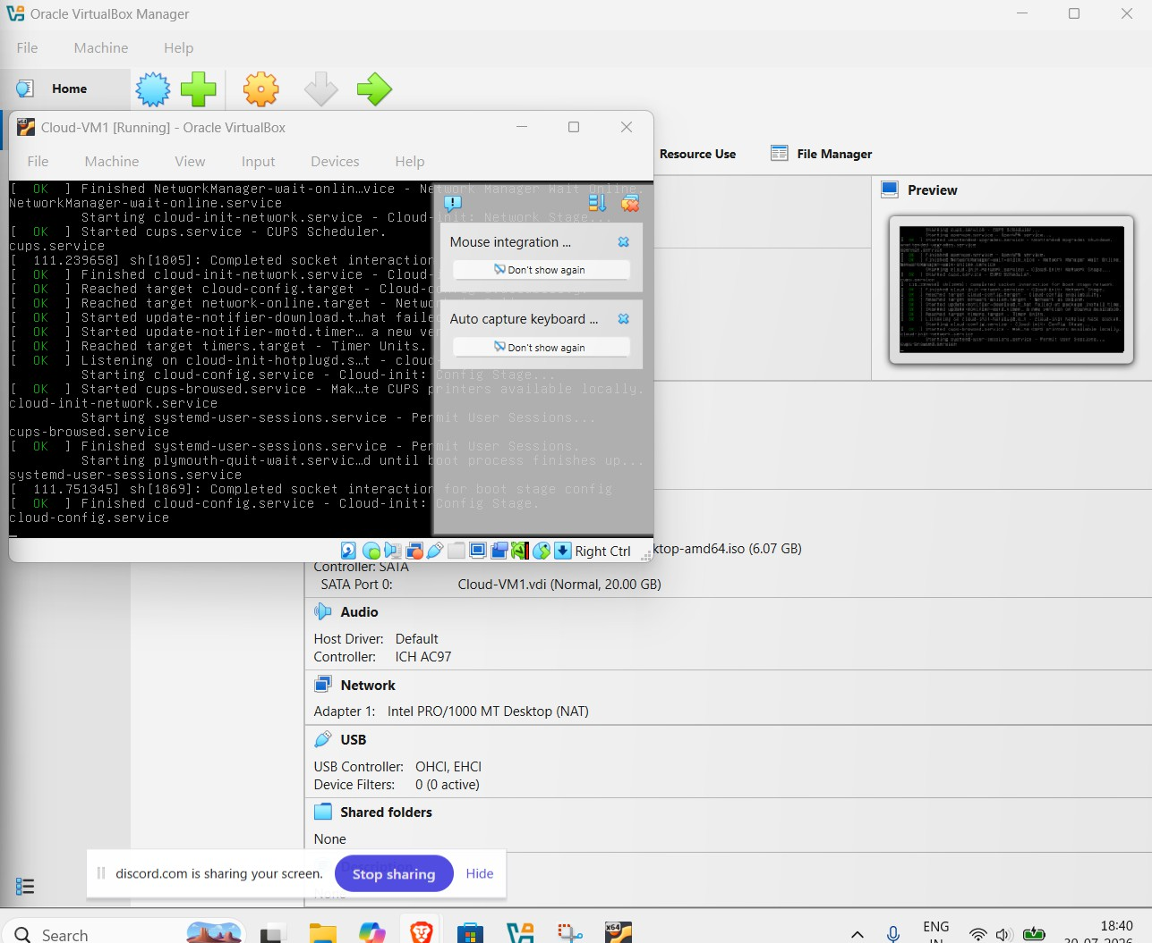

Step 3: Update the Ubuntu packages: sudo apt update ; sudo apt upgrade
Step 4: Install MicroStack (Beta channel): sudo snap install microstack --beta
Step 5: Check whether MicroStack has been installed successfully: snap list microstack
Step 6: Initialize the OpenStack services automatically by executing the following command: sudo microstack init
--auto --control

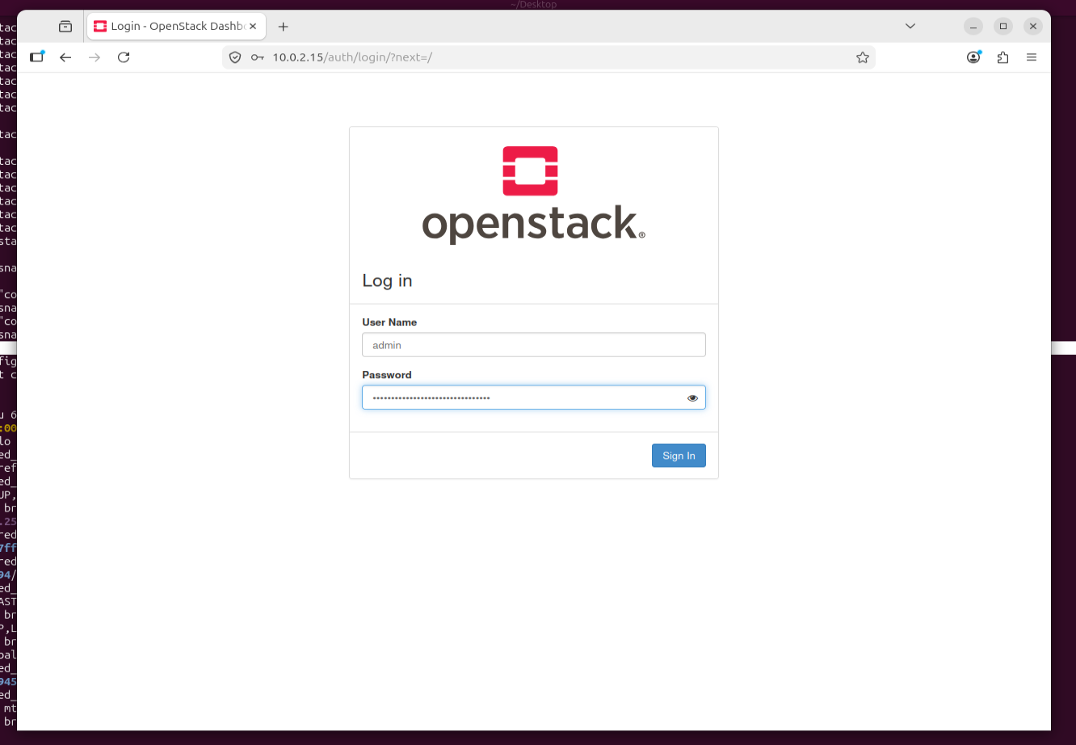

Step 7: Verify the installed OpenStack version: microstack.openstack --version
Step 8: Retrieve the Keystone administrator password: sudo snap get microstack config.credentials.keystone-password
Step 9: Open the OpenStack Horizon Dashboard in the web browser using the IP address provided after initialization and log in using:
- Username: admin
- Password: (obtained from the previous command)

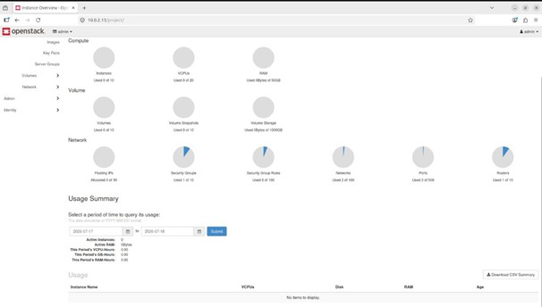

Conclusion
OpenStack (MicroStack) was successfully installed and configured on Ubuntu, and the Horizon Dashboard was accessed.

Ex: 2 | PaaS in Public Cloud Using Render
Date:8/7/2026 | PaaS in Public Cloud Using Render

Aim
To build a basic Python Flask web application and deploy it on the Render cloud platform. This experiment helps in understanding how a Platform as a Service (PaaS) allows applications to run online without manually setting up or maintaining servers.

What is PaaS?
Platform as a Service (PaaS) is a cloud service that provides everything needed to develop, deploy, and run an application. It takes care of server management, software installation, and deployment, allowing developers to focus only on writing the application.

Why Render?
Render is an easy-to-use cloud hosting platform that supports web application deployment directly from GitHub. It automatically builds and hosts the application, making deployment simple even for beginners.

Procedure
Step 1: Sign in to your GitHub account or create one if you do not already have an account.
Step 2: Create a project folder named RenderHelloApp.
Step 3: Inside the project folder, create the following files:
- app.py
- requirements.txt
Step 4: Write the Flask application code in the app.py file.
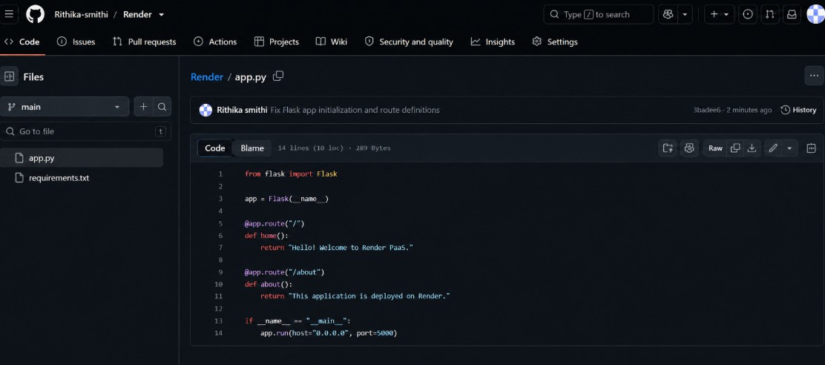
Step 5: Add the required Python packages such as Flask and Gunicorn to the requirements.txt file.

Step 6: Create a new public repository called RenderHelloApp on GitHub. Step 7: Upload both project files to the repository and commit the changes. Step 8: Create an account on Render and connect it to your GitHub account.
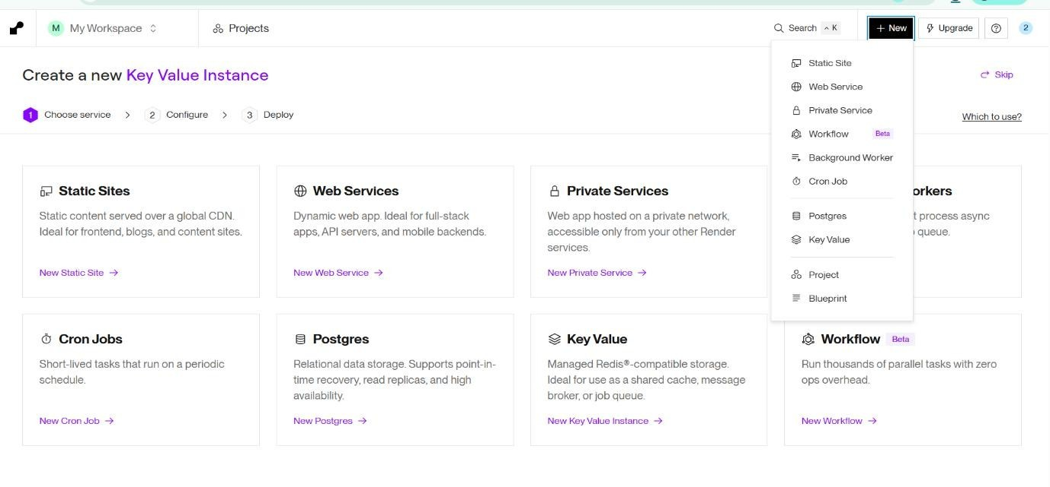
Step 9: Create a new Web Service in Render.
Step 10: Select the RenderHelloApp repository from GitHub.
Step 11: Enter the deployment details:
- Language: Python
- Branch: main
- Root Directory: Leave empty
- Build Command: pip install -r requirements.txt
- Start Command: gunicorn app:app
- Instance Type: Free (if available)

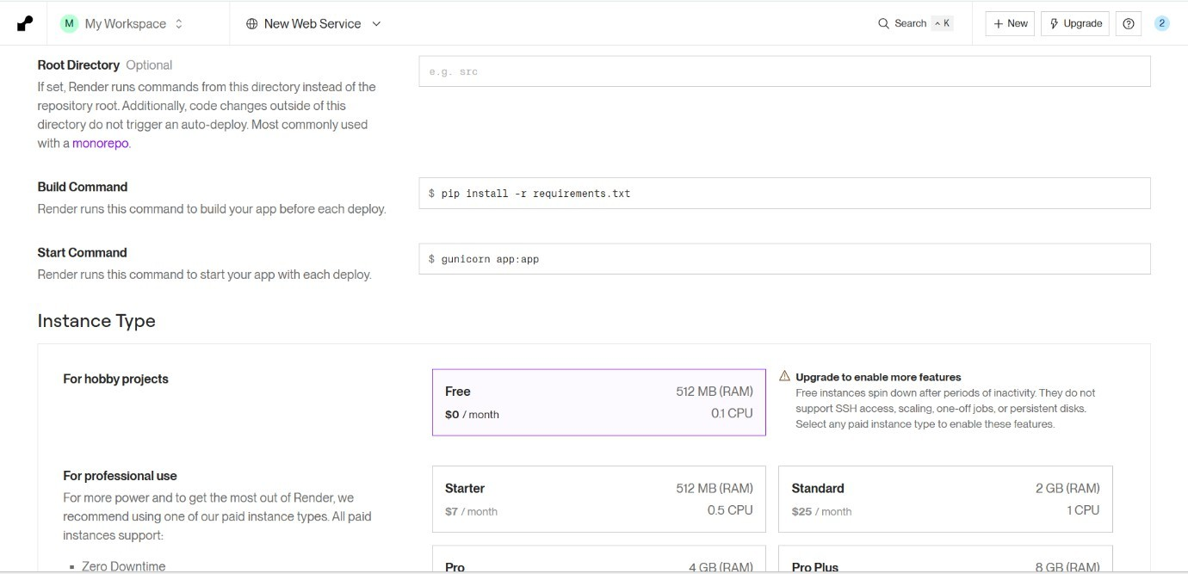
Step 12: Click Deploy Web Service and wait for the deployment to complete.
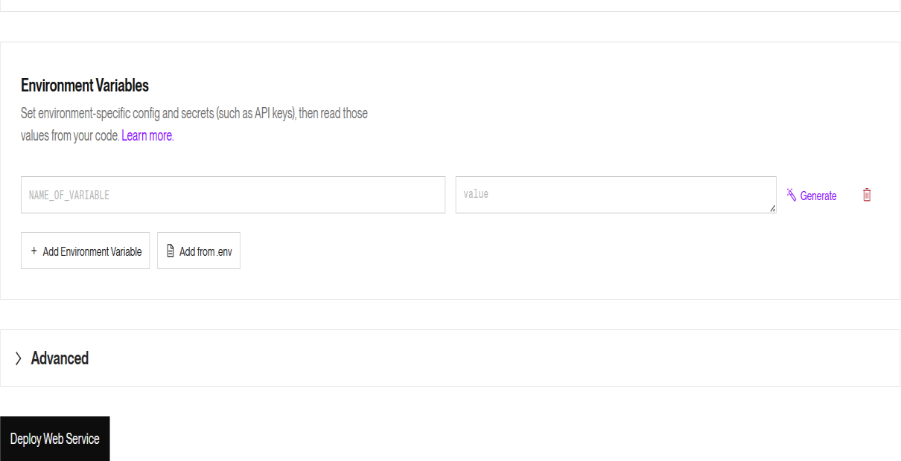
Step 13: After deployment, open the URL generated by Render and check whether the home page is displayed correctly.
Step 14: Add /about at the end of the application URL to verify that the second route is also working properly.

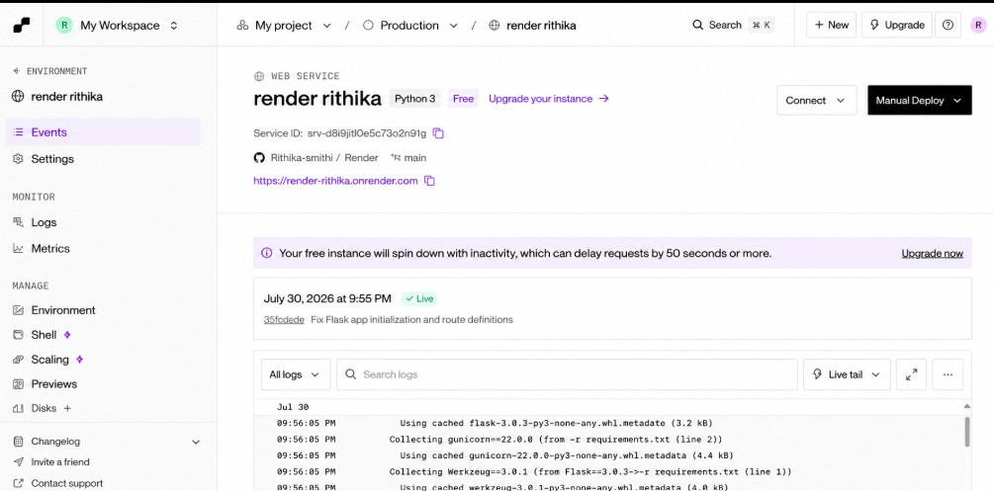
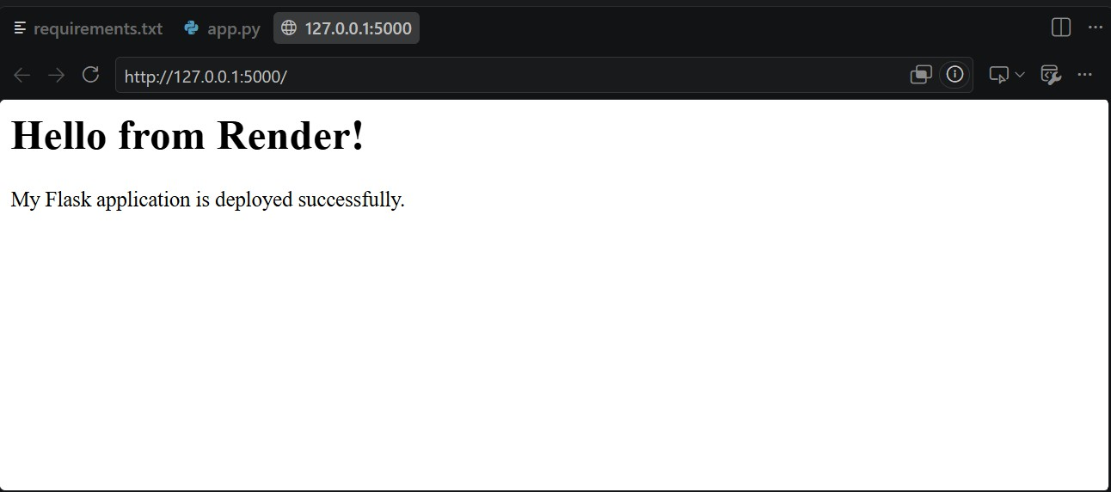

Conclusion
This experiment demonstrated how a Flask application can be deployed using Render, a Platform as a Service. I learned that PaaS simplifies application deployment by handling the server setup and hosting, allowing developers to publish applications quickly without managing infrastructure.

Ex: 3 | Setting Up Hybrid Cloud Connectivity Using Cisco Packet Tracer (Simulation)
Date:22/7/2026

Aim
To simulate a secure hybrid cloud connection between an on-premises data center and a cloud network using routers, switches, subnets, and routing in Cisco Packet Tracer.

Procedure
Step 1: Open Cisco Networking Academy. Go to: https://www.netacad.com

Step 2: Create a Free Account or Sign in with your Google Account.
- Click Create an account (or Sign up).
- Enter: First Name, Last Name, Email Address, Password.
- Verify your email if prompted.
- Sign in.
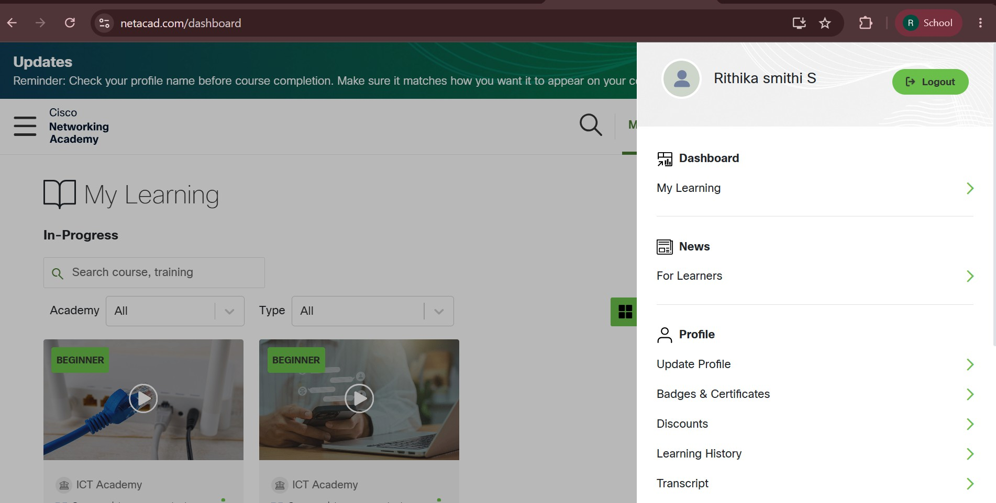

Step 3: Enroll in the Free Packet Tracer Course.

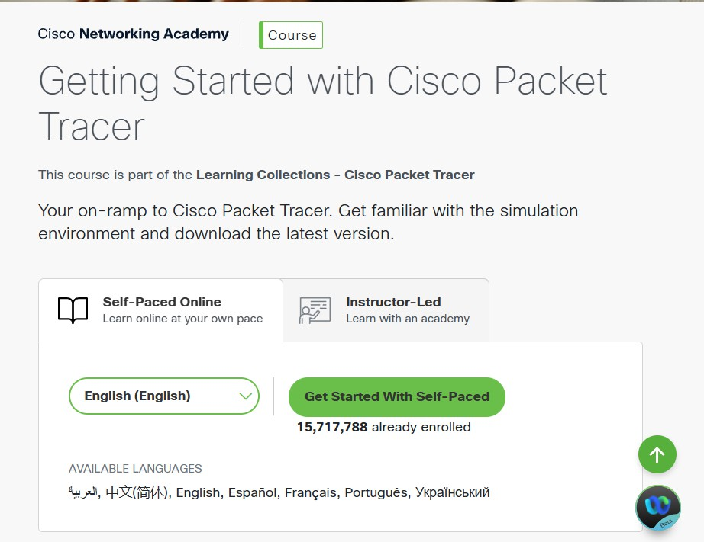
Step 4: Download Packet Tracer. After enrolling:
- Go to your NetAcad Dashboard.
- Open the Getting Started with Cisco Packet Tracer course.
- Navigate to the Resources or Downloads section.
- Download the version for your operating system: Windows 64-bit (recommended for most PCs), macOS, Linux.
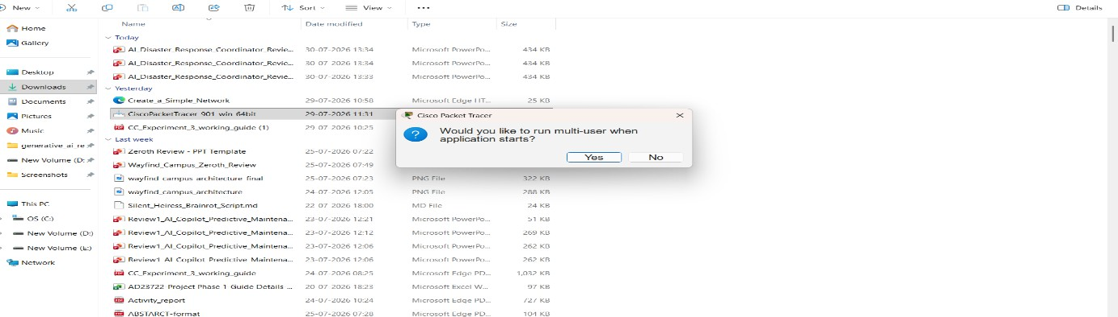

Step 5: Install Packet Tracer.
- Open the downloaded installer (.exe on Windows).
- Click Next.
- Accept the license agreement.
- Click Next until installation completes.
- Click Finish.

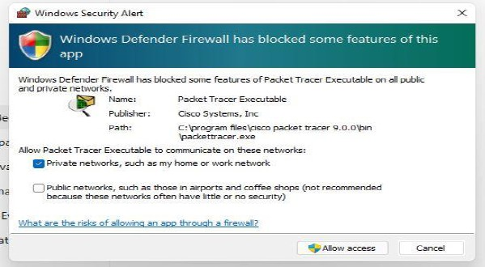
Step 6: Start Packet Tracer. Open Cisco Packet Tracer from the Start Menu. Sign in with your Cisco NetAcad account or sign in with your google account.
Step 7: Place Two Routers. At the bottom-left of Packet Tracer, you'll see several icons.
- Click Network Devices (the router icon).
- Click Routers.
- Choose 2911 (or 1941 if 2911 isn't available).
- Click once in the blank workspace to place the first router and second one.
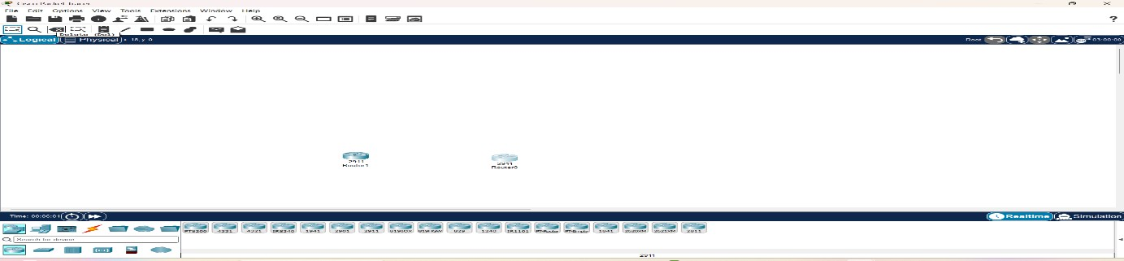

Step 8: Place Two Switches.
- At the bottom-left, click Network Devices.
- Click Switches.
- Select 2960 (for example, 2960-24TT).
- Place one switch below Router0.
- Place another switch below Router1.

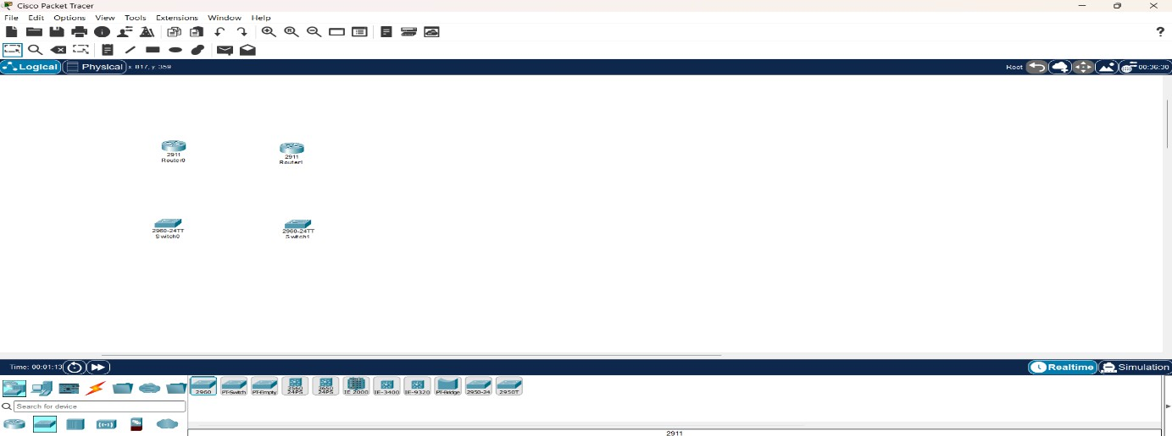

Step 9: Place One PC and One Server.
- At the bottom-left, click End Devices (computer icon).
- Select PC.
- Place it to the left of Switch0.
- Select Server.
- Place it to the right of Switch1.
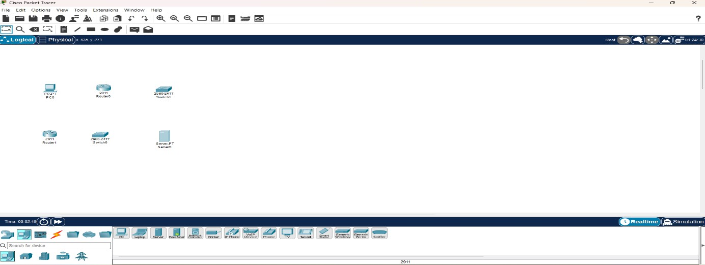
Step 10: Connect the Devices. At the bottom-left, click the Connections icon (lightning bolt). Choose Copper Straight-Through (usually the first black cable).

Connection 1: PC to Switch0
1. Click PC. 2. Select FastEthernet0. 3. Click Switch0. 4. Select FastEthernet0/1 (or any free FastEthernet port).
Connection 2: Switch0 to Router0 — Using the same Copper Straight-Through cable:
1. Click Switch0. 2. Select FastEthernet0/2. 3. Click Router0. 4. Select GigabitEthernet0/0.
Connection 3: Server to Switch1 — Again use Copper Straight-Through:
1. Click Server. 2. Select FastEthernet0. 3. Click Switch1. 4. Select FastEthernet0/1.
Connection 4: Switch1 to Router1 — Again use Copper Straight-Through:

1. Click Switch1. 2. Select FastEthernet0/2. 3. Click Router1. 4. Select GigabitEthernet0/0.
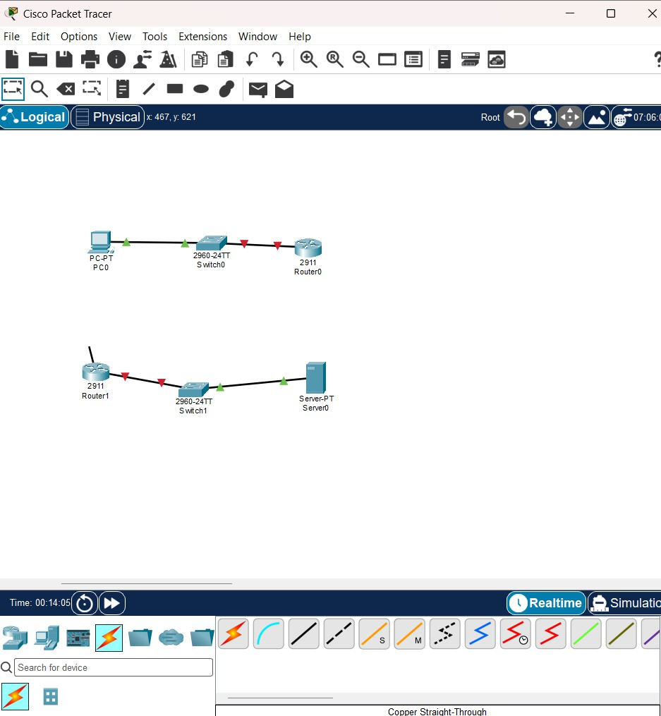
Step 10.1: Connect Router0 to Router1. Now connect the two routers.
Option A (Recommended) — Use Copper Cross-Over.
1. Click the Connections icon. 2. Select Copper Cross-Over. 3. Click Router0. 4. Select GigabitEthernet0/1. 5. Click Router1. 6. Select GigabitEthernet0/1.
Your topology should now look like this:

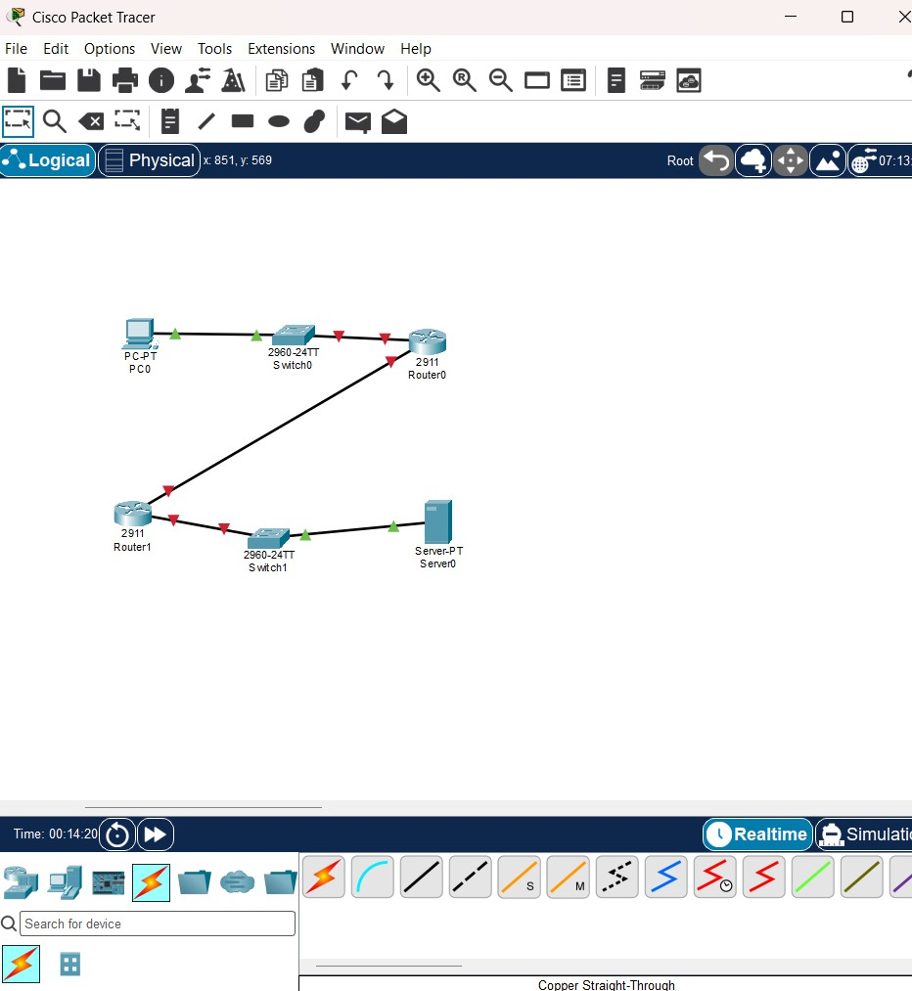
Step 10.2: Click the Router. In your workspace, left-click Router0 once.
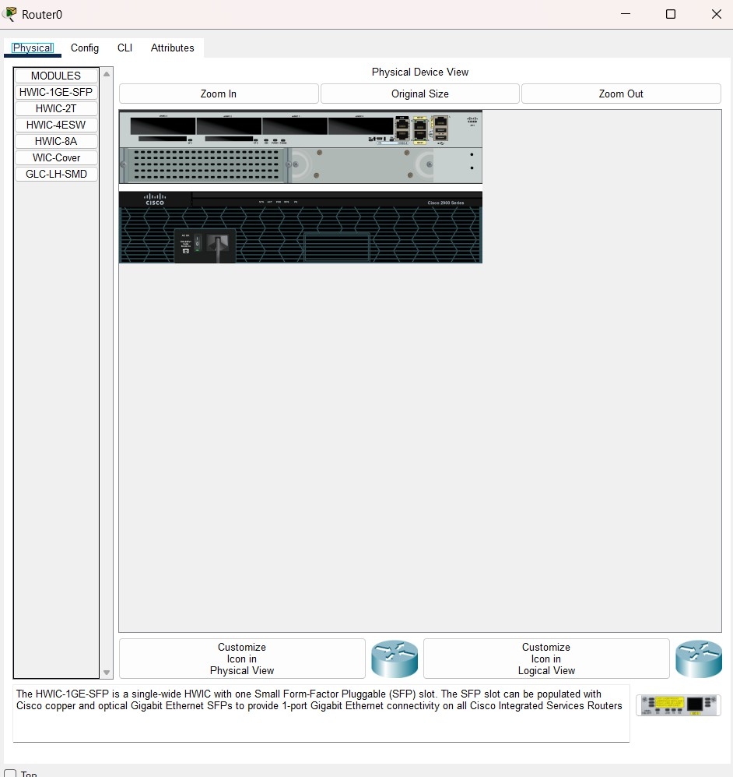
- Click the CLI tab.

- If it asks: "Continue with configuration dialog? [yes/no]:" Type: no. Press Enter. When you see: Router>
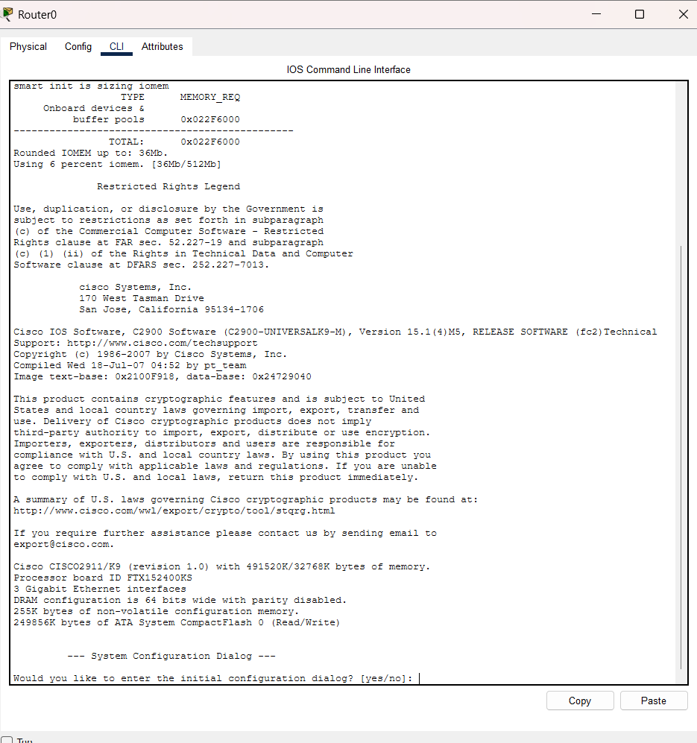
Step 10.3: Configure the LAN Interface (Connected to Switch0). At the Router(config)# prompt, type these commands one at a time, pressing Enter after each line.
interface gigabitEthernet0/0 — You should see: Router(config-if)# Now type: ip address 192.168.1.1 255.255.255.0 — Press Enter.
Now type: no shutdown — You should see a message similar to: Now

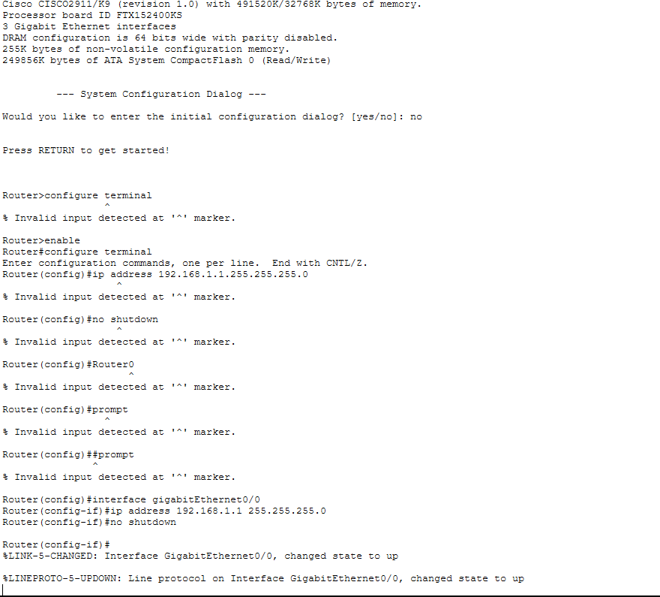
Step 10.4: Configure the Router-to-Router Interface. Now type: interface gigabitEthernet0/1 Then: ip address 10.10.10.1 255.255.255.252
Then: no shutdown — Again, wait for the interface to come up. Finally, type: exit — You should now be back at: Router(config)#
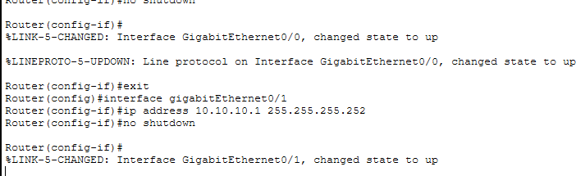
Step 10.5: Verify the Configuration. Type: do show ip interface brief — Since you're in configuration mode, use do before the show command. You should see something similar to:

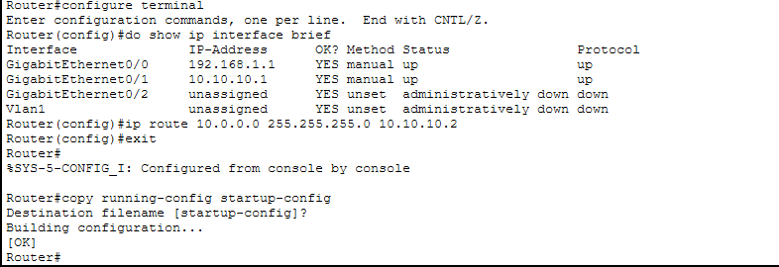
Next Step: Configure Router1. Click Router1 → CLI. If it says: "Press RETURN to get started!" Press Enter. If it asks: "Continue with configuration dialog? [yes/no]:" Type: no
Then enter these commands one by one: enable; configure terminal; interface gigabitEthernet0/0; ip address
10.0.0.1 255.255.255.0; no shutdown; exit; interface gigabitEthernet0/1; ip address
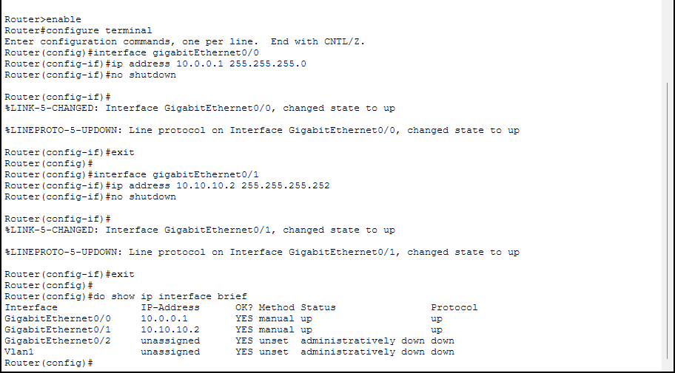

Step 10.6: Configure the PC.
1. Click PC. 2. Select Desktop. 3. Click IP Configuration.

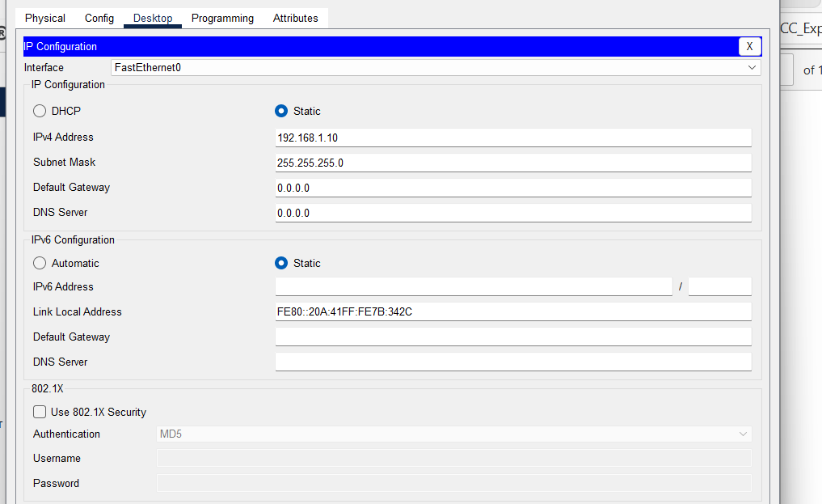

Step 10.7: Configure the Server.
1. Click Server. 2. Select Desktop. 3. Click IP Configuration.
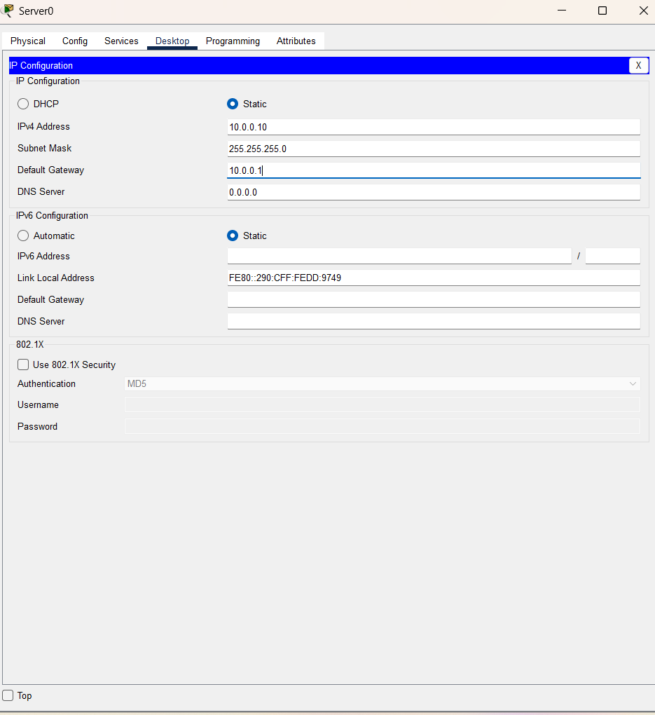

Step 11: Configure Static Routes.
- Configure Static Route on Router0
1. Click Router0. 2. Go to the CLI tab. 3. If you're at Router#, type: configure terminal Now enter: ip route 10.0.0.0 255.255.255.0 10.10.10.2
Exit configuration mode: exit — Save the configuration: copy running-config startup-config — When prompted: "Destination filename [startup-config]?" Just press Enter.

Configure Static Route on Router1
  - Click Router1. 2. Open the CLI. At the Router# prompt, type: configure terminal Now enter: ip route 192.168.1.0 255.255.255.0 10.10.10.1
Exit: exit — Save the configuration: copy running-config startup-config — When prompted for the filename, simply press Enter.
- Verify the Route — Type: show ip route
You should see a line similar to: S 192.168.1.0/24 [1/0] via 10.10.10.1 — The S indicates that the static route has been added successfully.
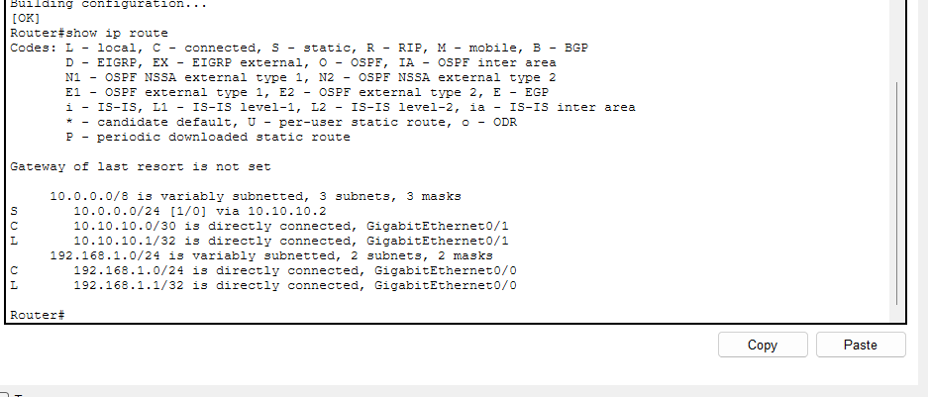
Now let's verify Router0. On Router0, at the Router# prompt, type: show ip route

You should see a line like: S 10.0.0.0/24 [1/0] via 10.10.10.2 — If you don't see it, add the route: configure terminal; ip route 10.0.0.0 255.255.255.0 10.10.10.2; end; copy running-config startup-config. Press Enter when it asks for the destination filename.
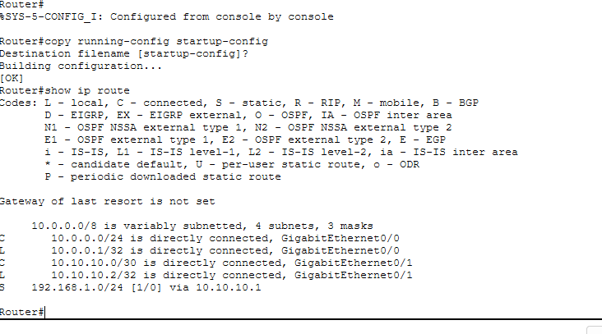
Step 12: Test Connectivity. From the PC:
1. Click PC. 2. Go to Desktop → Command Prompt. 3. Type: ping 10.0.0.10 4. Type one more time: ping 10.0.0.10

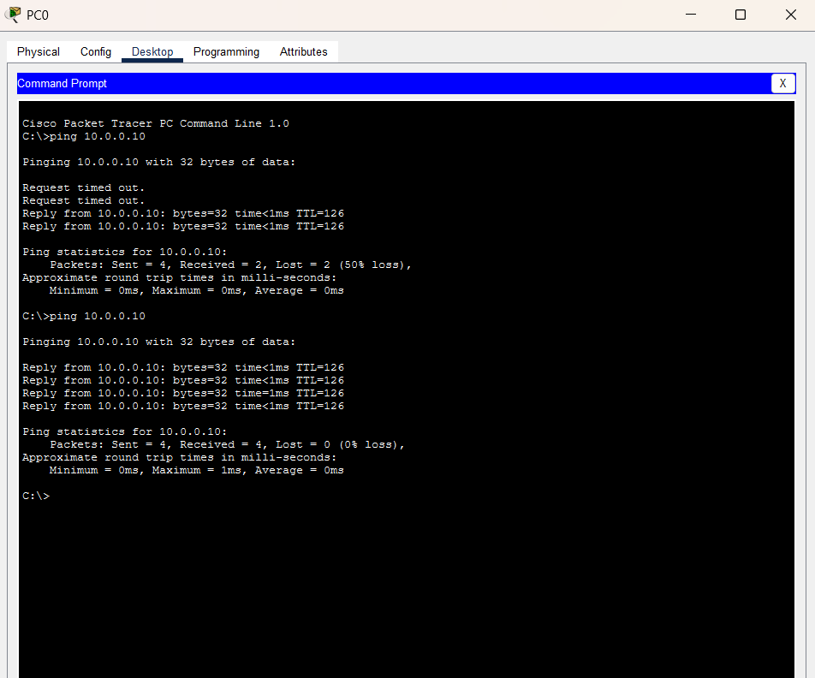
Experiment Successfully Completed! You have successfully simulated Hybrid Cloud Connectivity.

Result
A hybrid cloud network was successfully simulated using Cisco Packet Tracer. The on-premises network and cloud network were interconnected through routers configured with static routing. Communication between the PC and the
cloud server was verified successfully using the ping command, demonstrating end-to-end connectivity.

Ex: 4 | Virtual Private Server (VPS) Provisioning and Configuration
Date:5/8/2026 | Virtual Private Server (VPS) Provisioning and Configuration

Aim
To provision a Virtual Private Server (VPS) using VirtualBox, install Ubuntu Server, configure network settings (IP Address, Subnet Mask, Gateway, DNS), and enable SSH remote access.

What is VPS?
A Virtual Private Server (VPS) is a software-based server created using virtualization technology. It operates independently with its own operating system, storage, memory, and network configuration while sharing the physical hardware with other virtual machines. Virtualization allows efficient utilization of resources and forms the foundation of cloud computing platforms. Network configuration parameters include:

IP Address
A unique address assigned to a device on a network.

Subnet Mask
Determines the network and host portions of an IP address.

Gateway
Provides access to networks outside the local network.

DNS (Domain Name System)
Converts domain names into IP addresses.

SSH (Secure Shell)
A secure protocol used for remote administration of Linux systems.

Procedure
- Open the Ubuntu terminal and verify the internet connection using the ping google.com command.

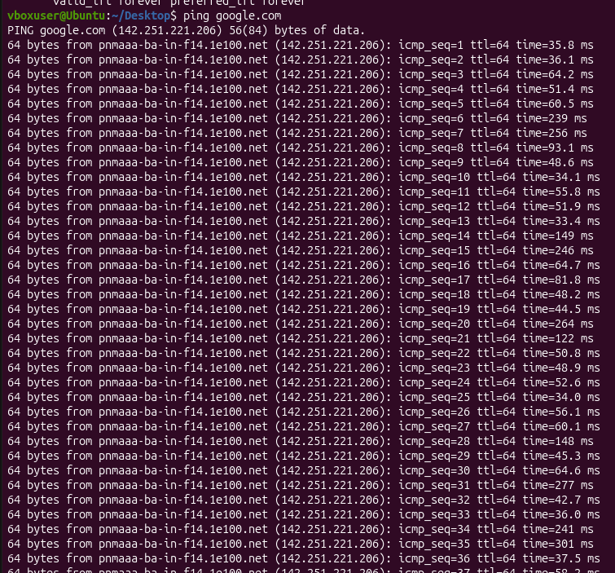
- Check the network routing information using the ip route command.
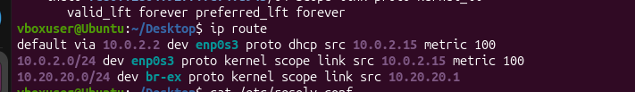
- Verify the DNS (Domain Name System) configuration of the system using the cat /etc/resolv.conf command.

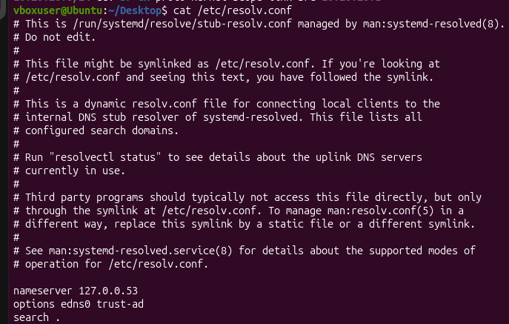
- Update the Ubuntu package list (if required) using: sudo apt update
- Install the OpenSSH Server package using: sudo apt install openssh-server -y
- Enable and start the SSH service using: sudo systemctl enable ssh ; sudo systemctl start ssh
- Check whether the SSH service is running successfully using: sudo systemctl status
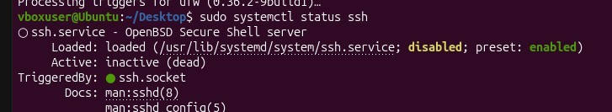
- Find the IP address of the Ubuntu system using: hostname -I
- Establish an SSH connection to the Ubuntu system using: ssh <username>@<IP_address>

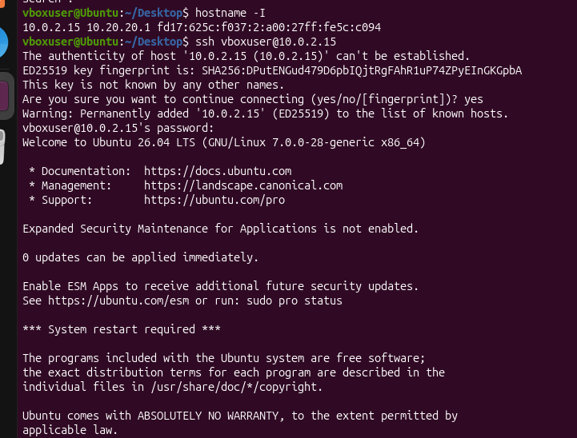
- Verify the successful SSH login by checking the "Welcome to Ubuntu" message displayed on the terminal.

Conclusion
The Ubuntu system was successfully configured and verified for network connectivity. The OpenSSH Server was installed and enabled, and the SSH service was confirmed to be running. The system's IP address was obtained, and a successful SSH login was performed. Thus, secure remote access to the Ubuntu system was successfully established and verified.

Ex: 5 | Cloud Backup and Migration using Google Drive
Date:14/8/2026 | Cloud Backup and Migration using Google Drive

Aim
To establish a cloud-based backup solution by utilizing Google Drive, configuring automated synchronization for essential files, and confirming the integrity of the backed-up data.

Procedure
- Create a local directory designated as "OfficeData" on your workstation.
- Generate three files named Student.txt, Attendance.txt, and Marks.txt within this directory, populated with example data.
- Access your Google Drive account via a web browser.
- Create a dedicated directory titled "CloudBackup" within your Google Drive storage.
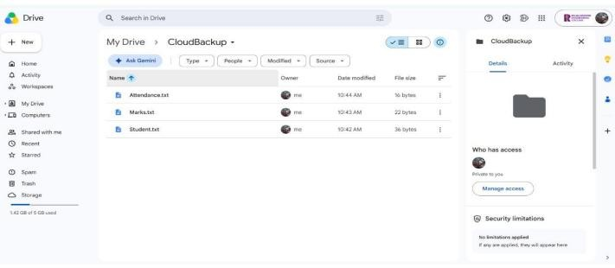
- Upload the three previously created files into this new CloudBackup directory.

- Download and install the "Google Drive for Desktop" application, ensuring you sign in with the same credentials used in the browser.
- Within the Drive for Desktop settings, select the "OfficeData" folder and activate the synchronization feature.

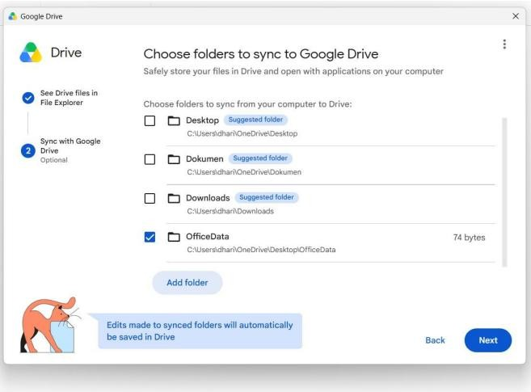
- Verify that the local "OfficeData" folder content now appears within your synced Google Drive files.
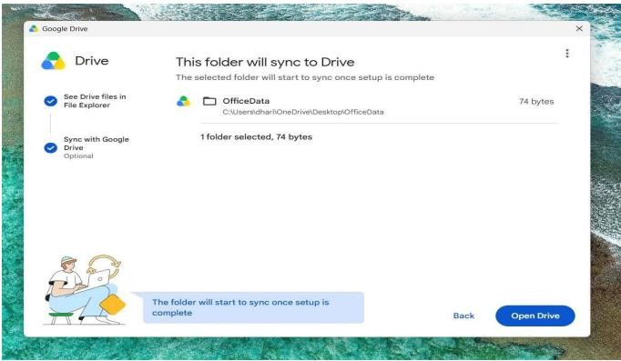
- Update Student.txt locally by appending the text "Cloud Backup Test - Successfully Synchronized" and save the changes.
- Monitor the synchronization status in the system tray until it displays "Up to date" or confirms a successful upload.

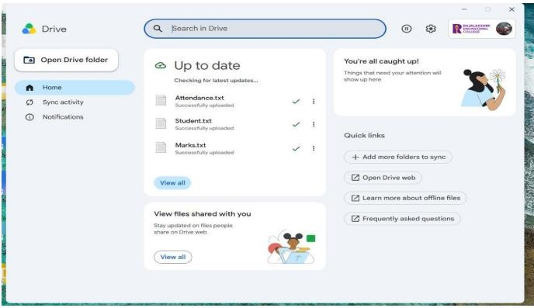
- Open the file in Google Drive via the web interface to confirm that the changes made locally are reflected in the cloud version.
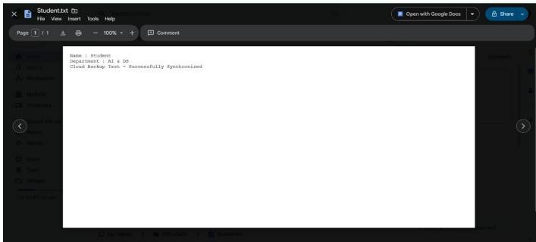

Conclusion
A robust cloud backup strategy was successfully deployed using Google Drive. By migrating local files and enabling persistent, automated synchronization, the integrity and availability of the data were verified, effectively demonstrating a reliable cloud-based recovery and backup mechanism.

Ex: 6 | CDN Service Selection and Configuration
Date:21/08/2026 | CDN Service Selection and Configuration

Aim
To implement a Content Delivery Network (CDN) by selecting a service provider, deploying a simple web application using Cloudflare, and validating the application’s delivery via the edge network by inspecting HTTP response headers using browser developer tools.

Procedure
- Choose a CDN Provider: Cloudflare was selected for its comprehensive suite of edge computing, DNS, security, and CDN capabilities.
- Access Cloudflare Dashboard: Log in to the Cloudflare management console. No modifications to DNS records or nameservers are required for this deployment.
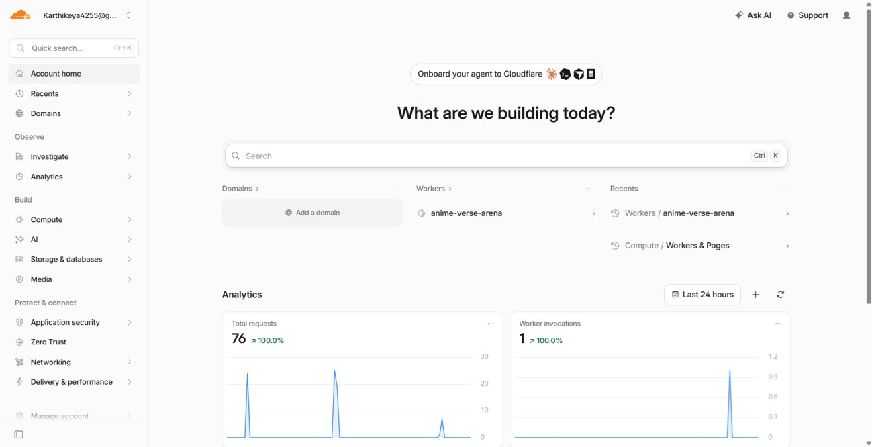
- Initialize a Worker: Navigate to the Cloudflare dashboard, select the option to create a new application, and choose the created repo to initialize a new Worker.

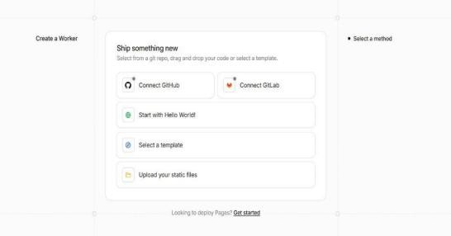

- Configure the Worker: Retain the default name and the pre-generated repo source code as provided by the platform.
- Deploy the Application: Click the deployment button and allow Cloudflare to complete the process, which generates a public URL ending in 'workers.dev'.
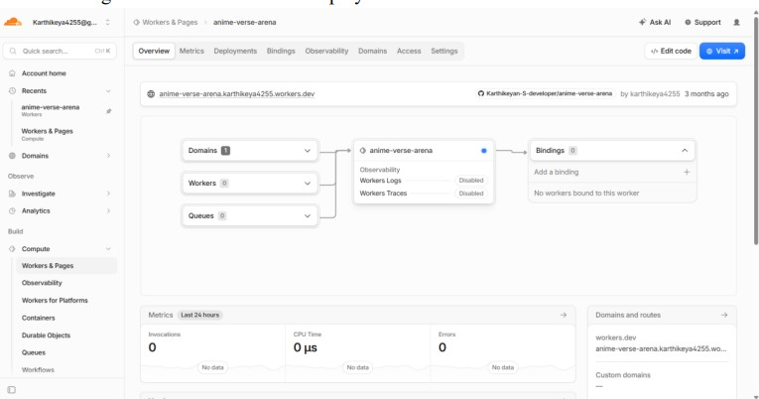

- Verify Initial Deployment: Select "Visit" to open the URL in a browser tab and confirm that the website is displayed.

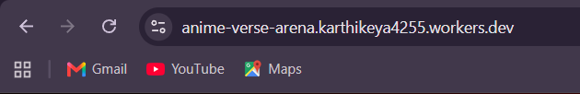

- Monitor Invocations: Return to the Cloudflare dashboard's analytics section to verify that the invocation count has increased, confirming successful traffic processing.
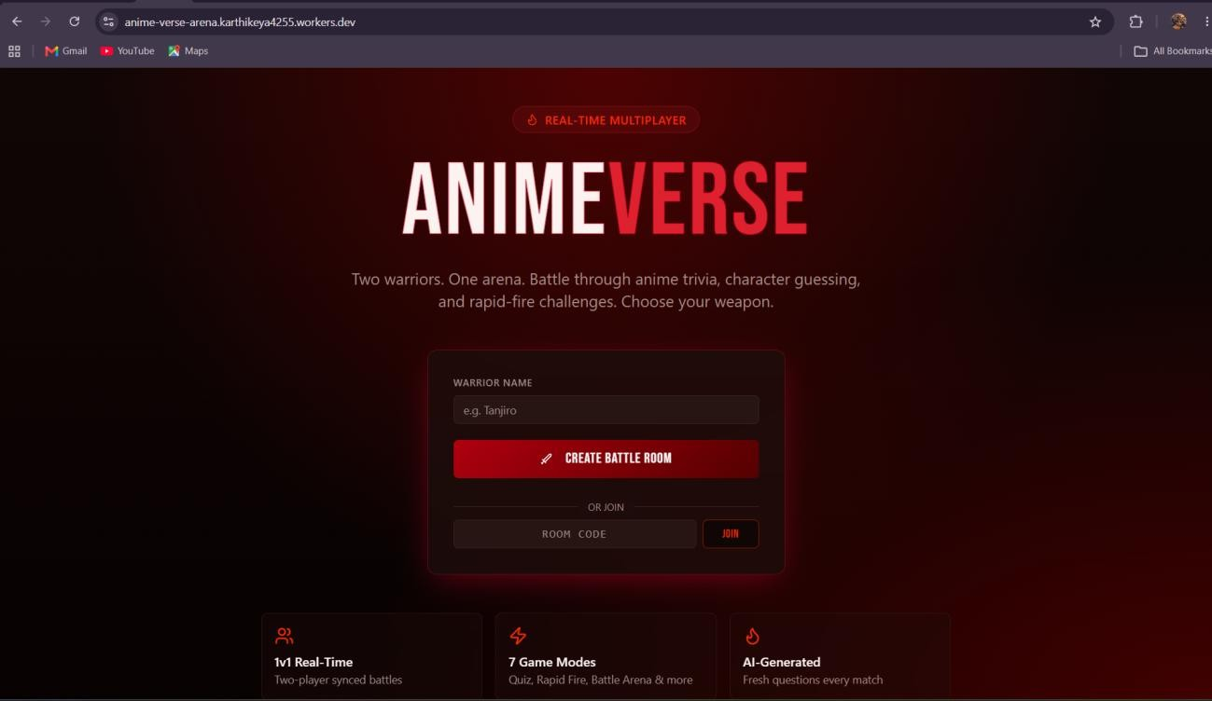
- Create Custom Experiment Page: Open the code editor, replace the boilerplate code with a custom HTML structure describing the CDN service experiment, and re-deploy.
- Test CDN Webpage: Click "Visit" once more to load the customized CDN experiment webpage in your browser.
- Analyze HTTP Response: Open the webpage, press F12 to access Developer Tools, navigate to the "Network" tab, and refresh the page (Ctrl + R). Select the request associated with the 'workers.dev' URL.
- Review Response Headers: Within the "Headers" section, inspect the following:
  - Request Method: GET
  - Status Code: 200 OK
  - Server: cloudflare
  - CF-Ray
  - Content-Type: text/html
- Confirm Successful Delivery: The 200 OK status code and the presence of specific Cloudflare headers verify that the content was successfully routed and served through the Cloudflare edge network.

Conclusion
The experiment successfully demonstrated the deployment of an application via Cloudflare Workers. By generating a public URL and validating the HTTP response headers (specifically verifying the 'Server: cloudflare' and 'CF-Ray' fields), it was confirmed that the application was effectively delivered through Cloudflare’s global edge network.

